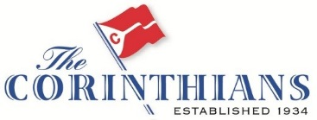

Long Island Sound Fleet Winter Gam Dinner Series 2018-2019
1830 hours - 2nd Thursday

Oct 11, Nov 8, Dec 13, Jan 10, Feb 14, Mar 14 and Apr 11

Let’s welcome the Long Island Sound Fleet as an officially recognized fleet of the Corinthians! For a second year the fleet will assemble for the off season through monthly gams. Meet and greet members and prospective members the second Thursday of each month off the water to keep the sailing fever alive through the winter.

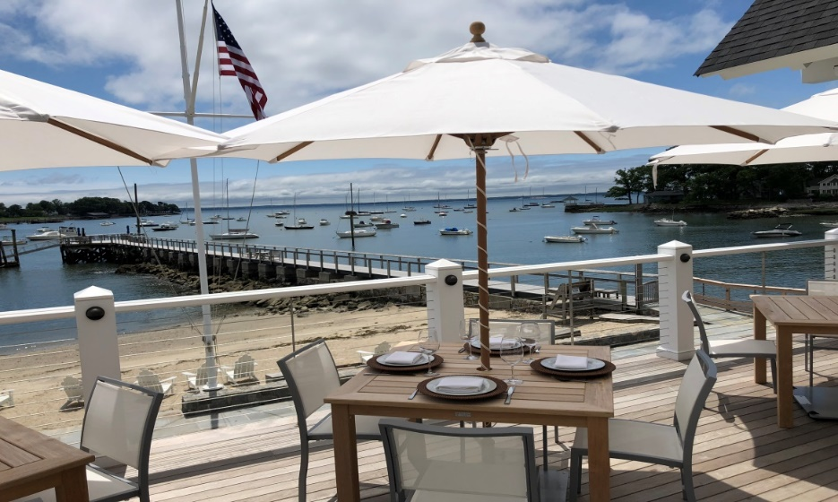
This year we will be moving to Noroton Yacht Club’s new facility and dining room in Noroton Bay on Darien Harbor from October through April except for January. On January 10th we will return to O’Neil’s in South Norwalk for just that month. Members and others from the local marine community will be solicited to speak at the Gams.

For speakers and Corinthian hosts please refer to the latest Jibsheet “Calendar of Events” and/or flyer updates. Speaker suggestions, host volunteers and Corinthian member guests are most welcome.

The courtesy of making reservations for each month’s event at TheCorinthians.org is appreciated. The Noroton Yacht Club will be issuing reciprocal guest cards with preregistered credit card numbers. All Corinthian members have to do to settle their bar and dinner tab is to show the guest card. You register once and come as often as you would like.

For directions: Noroton Yacht Club 23 Baywater Drive, Darien, CT 06820
O’Neill’s Pub and Restaurant 93 N Main Street, Norwalk, CT 06854

Corinthian contact: Bill Burnham Bill.Burnham@Deltanow.com 203-554-7478

